HTML:

PROGRAM1:

<html>

<head>

<title> simple html file </title>

</head>

<body bgcolor="lightblue">

<center>

<h1> simple tags heading H1</h1>

<h2> heading H2 </h2>

<h3> heading H3 </h3>

<b> this text is bold</b><br><br>

<i> this text is italic</i><br><br>

<p>this tag ,<mark>mark or highlighted!</mark></p><br>

<p align="justify">this is a paragraph The purpose of a web browser (Chrome, Edge, Firefox, Safari) is to read HTML documents and display them correctly.

A browser does not display the HTML tags</p>

<p>this is <sub> subscrpted</sub> text</p><br><br>

<p>this is <sup> superscripted </sup> text</p><br><br>

<img src="image1.jpg" height="300" width="400"><br><br>

<a href="pro 1.html">Link example</a><br><br>

</center>

<h2>type of Lists</h2>

<h3>UNORDERED</h3>

<ul>

<li>coffee</li>

<li>tea</li>

<li>milk</li>

</ul>

<h3>ORDERED</h3>

<ol>

<li>coffee</li>

<li>tea</li>

<li>milk</li>

</ol>

</body>

</html>

OUTPUT:

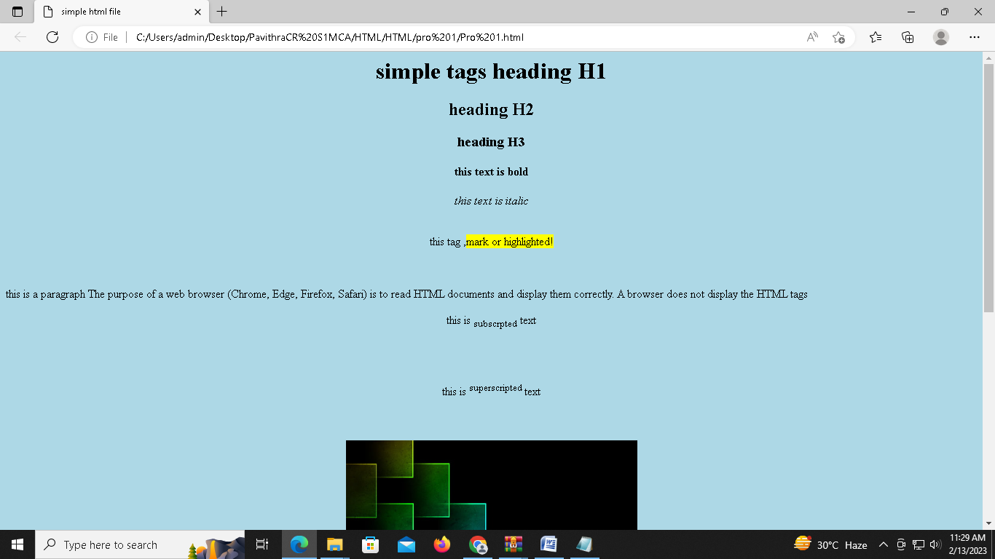

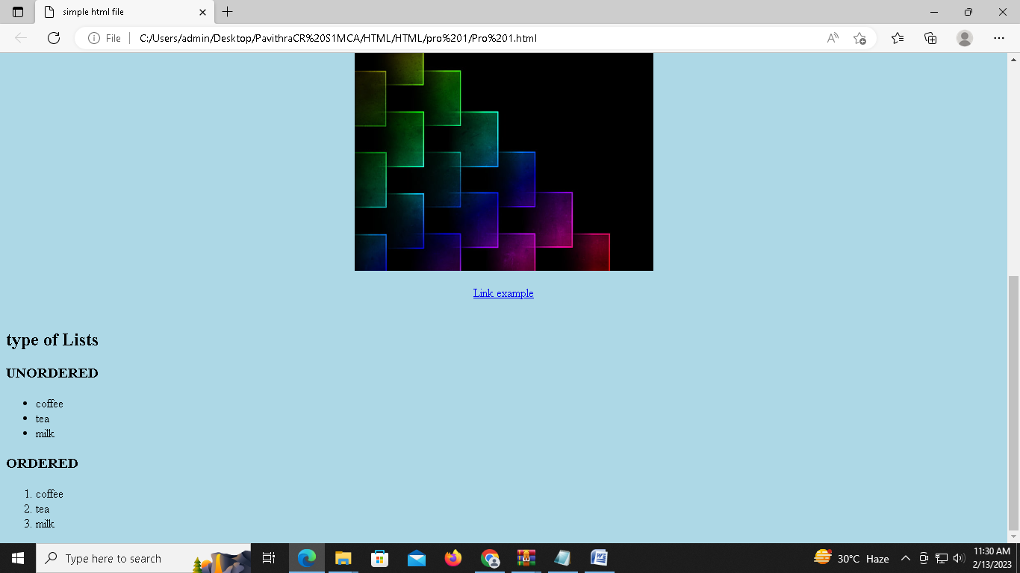

PROGRAM2:

Page1.html

<html>

<head>

<title>simple html page2</title>

</head>

<body bgcolor="lightgreen">

<center>

<h1>IMAGES</h1><br><br>

<img src="fish1.jpg" height="400" width="500">

<img src="fish2.jpg" height="400" width="500">

<br><br>

<a href="page2.html"> Go to next page </a>

</body>

</html>

Page2.html

<html>

<head>

<title>simple html page3</title>

</head>

<body bgcolor="lightblue">

<center>

<img src="fish3.jpg" height="400" width="500">

<h1> TABLES </H1>

<br><br>

<table border="1">

<tr>

<th> Regno&Name </th>

<th> Course </th>

<th colspan="2"> Mark Obtained </th>

<th> Total Marks </th>

</tr>

<tr>

<td rowspan="4" align="center"> 22011 <br> X </td>

<td rowspan="2" align="center"> ML </td>

<td> Internal </td>

<td> 39 </td>

<td rowspan="2" align="center"> 89 </td>

</tr>

<tr>

<td> External </td>

<td> 50 </td>

</tr>

<tr>

<td rowspan="2" align="center"> CN </td>

<td> Internal </td>

<td> 35 </td>

<td rowspan="2" align="center"> 80 </td>

</tr>

<tr>

<td> External </td>

<td> 45 </td>

</tr>

<tr>

<th colspan="4" align="right"> Grand Total </th>

<th> 169 </th>

</tr>

</table>

<br><br>

<a href="page1.html"> Go back to IMAGE page </a>

</body>

</html>

OUTPUT:

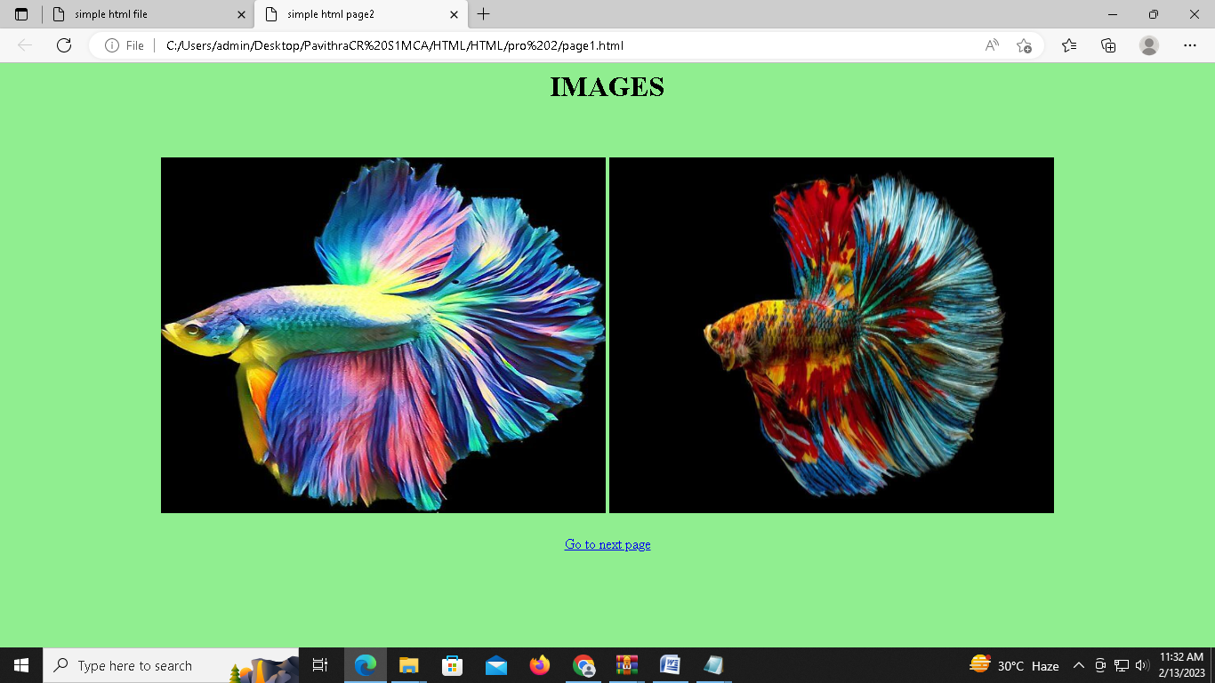

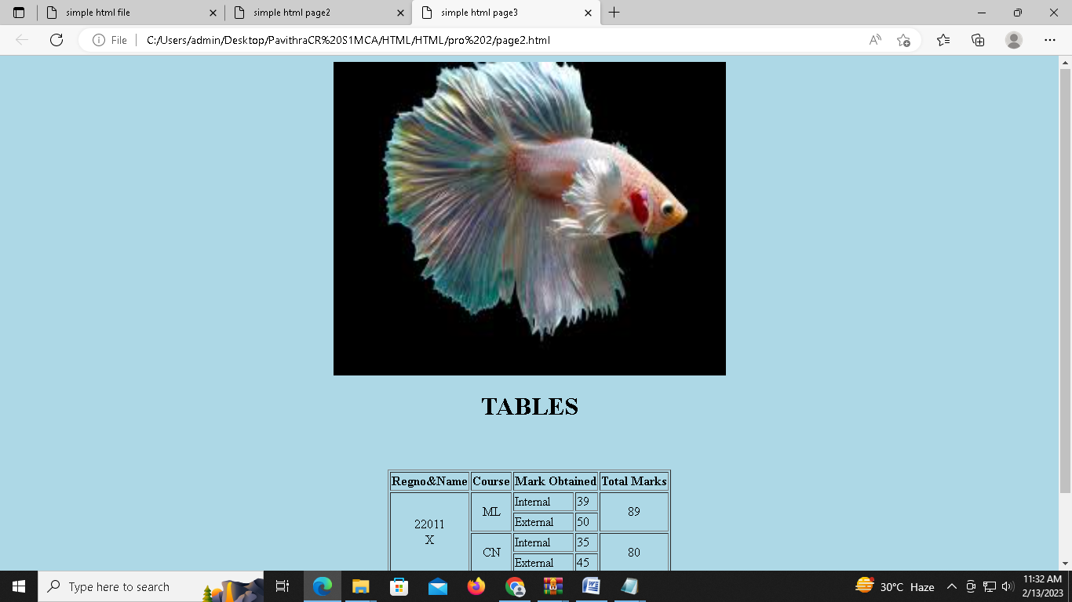

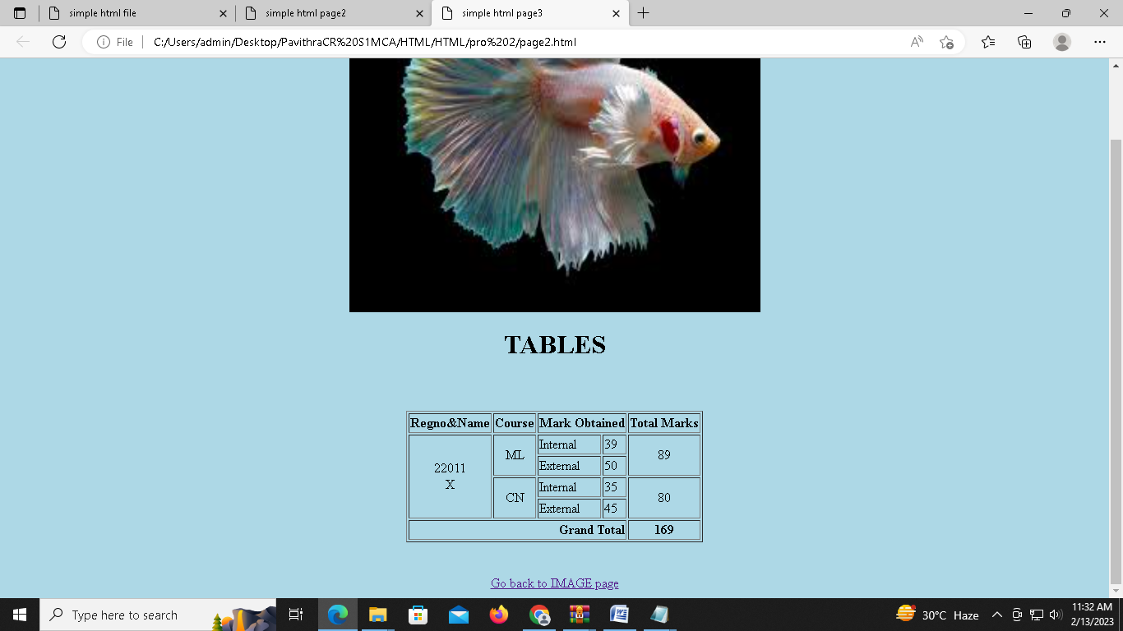

PROGRAM3

Dtl.html

<html>

<body bgcolor="pink">

<center>

<font size="6" color="blue">

<b>

<u> Master Of Computer Application </u>

</b>

</font>

</center>

<font size="5"><br>

<P align="justify">Department of Computer Applications started in the year 1999 offers full-time Master of Computer Applications program. This was the first MCA program to be offered in the self-financing sector in Kerala. Since its inception, it had been producing technical graduates whose presence have spanned the entire spectrum of Information Technology in India and abroad.

</p>

</font><br><br>

<center>

<img src="mca.jpg" height="250" width="550 " >

</center><br>

<font size="5">

<P align="justify">MCA at MESCE is a two-year (Four Semester) professional master’s degree in Computer Applications under APJ Abdul Kalam Technological University. The course has been structured in line with the prevailing technology of the industry. It teaches theory and gives due importance to practical knowledge. This program understands the scope and standards of the industry and accordingly creates software engineers to the current demand of the Industry.

</p>

</font>

<font size="6" color="blue">

<b>VISION</b>

</font><br>

<font size="5">

<ul>

<li><P align="justify">To facilitate transformation of students into competent professionals with human values and social commitment.</p></li>

</ul>

</font><br><br>

<font size="6" color="blue">

<b>MISSION</b>

</font><br>

<font size="5" >

<ul>

<li><P align="justify">To equip students to face the industry challenges.</p></li>

<li><P align="justify">To inculcate leadership qualities, human values and social responsibilities in the youth to make them leaders in nation building.</p></li>

<li><P align="justify">To build research interest in students and thereby contribute meaningfully to the prosperity of the nation.</p></li>

</ul>

</font><br><br>

<font size="6" color="blue">

<b>Curriculum </B>

</FONT><BR>

<table border="1" bgcolor="lavender" size="3">

<tr>

<th rowspan="2">Semester</th>

<th colspan="2"> Courses Offered </th>

<th rowspan="2">Credit</th>

<th colspan="3"> Marks Distribution </th>

</tr>

<tr>

<th>Name</th>

<th>Category</th>

<th>CIE</th>

<th>ESE</th>

<th>Total</th>

</tr>

<tr>

<td align="center" rowspan="2"> I </td>

<td>MFC</td>

<td>Theory</td>

<td>4</td>

<td>40</td>

<td>60</td>

<td>100</td>

</tr>

<tr>

<td>WPLAB</td>

<td>Practical</td>

<td>2</td>

<td>50</td>

<td>50</td>

<td>100</td>

</tr>

<tr>

<td colspan="3"></td>

<td>6</td>

<td>90</td>

<td>110</td>

<td>200</td>

</tr>

</body>

</html>

Frame.html

<html>

<head>

<title> MES </title>

</head>

<frameset rows="15%,85%">

<frame src="title.html">

<frameset cols="20%,80%">

<frame src="mca.html">

<frame src="right.html" name="frame3">

</html>

Mca.html

<html>

<body bgcolor="pink">

<CENTER><br><br><br><br><br><br><br><br><br><br><br><br><br><br>

<font color="blue" size="6">

<a href="dtl.html" target="frame3" > MCA </a>

</font>

</CENTER>

</BODY>

</HTML>

Right.html

<html>

<body bgcolor="pink">

<font color="blue" size="6">

<b><u> ABOUT MESCE </u></b>

</FONT>

<P align="justify"><font size="5"> M.E.S College of Engineering, the first Engineering College established under the self financing sector in Kerala is

situated on the beautiful and serene banks of Nila or Bharathapuzha. It was established as an institution with minority

status in 1994.</p>

<center>

<img src="mesce.jpg" align="center" hight="500" width="500">

<font size="5">

<P align="justify">Widely acknowledged as one of the premier institutions imparting technical education in the state, the college offers admission to all categories of students with special consideration to educationally backward communities....</p>

</FONT>

</CENTER>

</BODY>

</HTML>

Title.html

<html>

<body bgcolor="pink">

<CENTER><br>

<font color="blue" size="7"> MES COLLEGE OF ENGINEERING, KUTTIPURAM </font>

</CENTER>

</BODY>

</HTML>

OUTPUT:

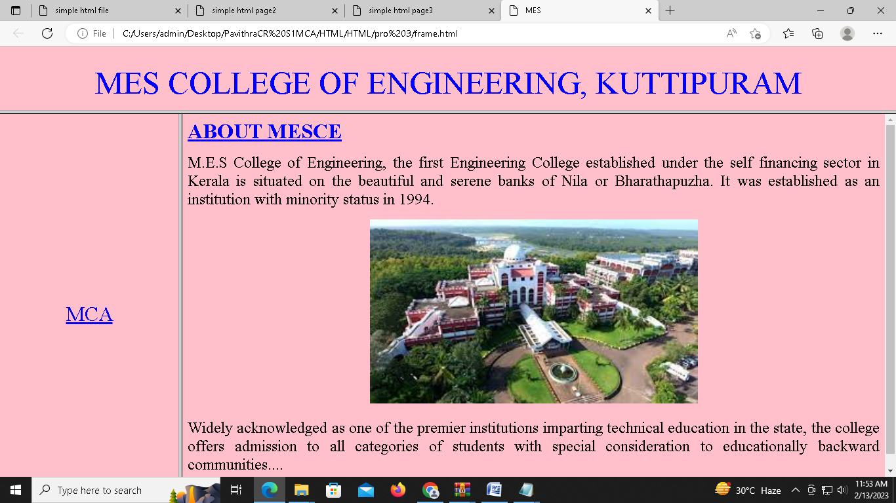

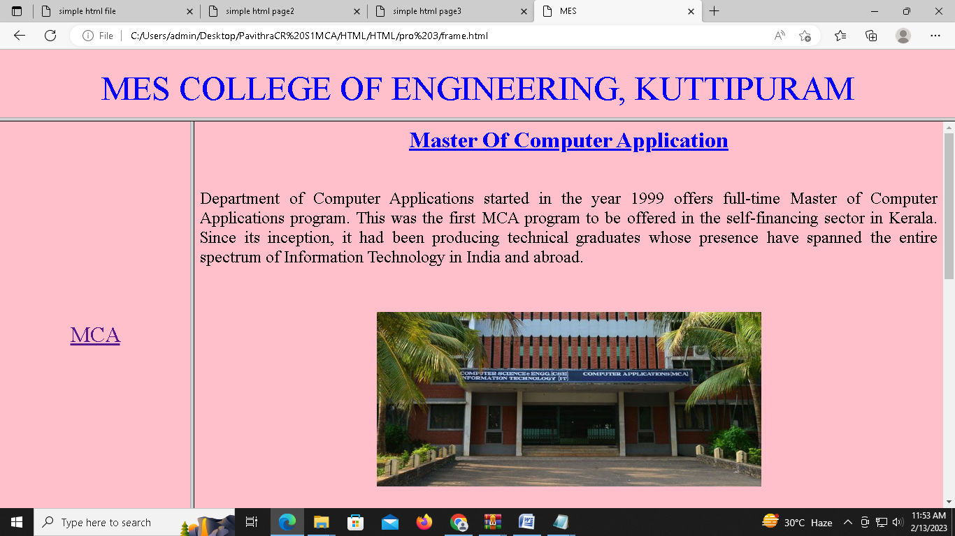

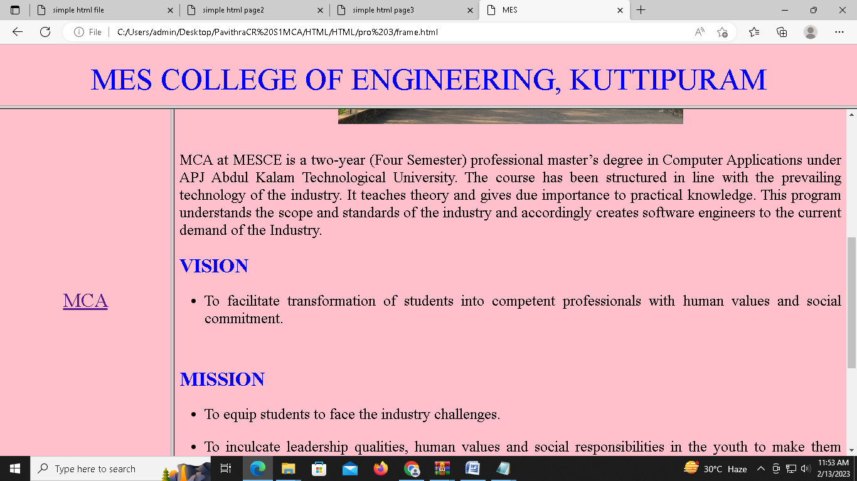

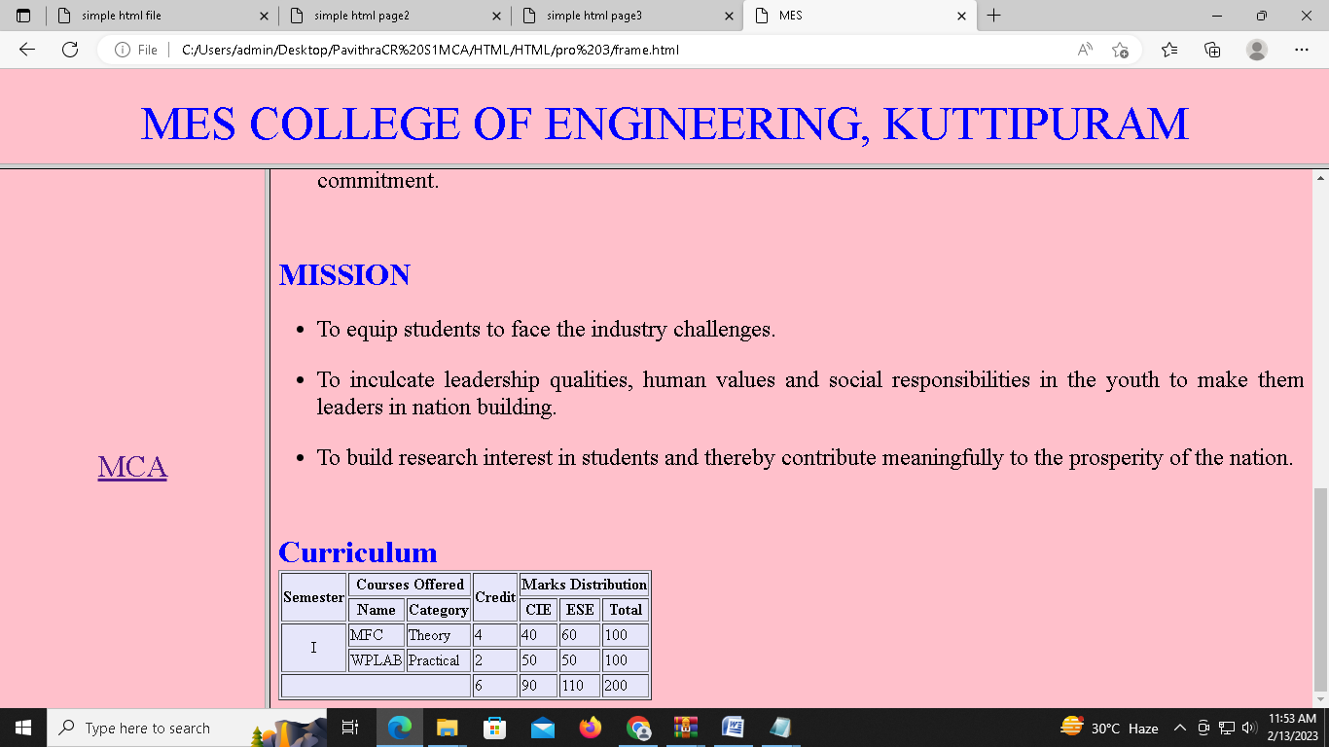

Program4:

External.css

body

{

background-color:lavender;

}

h1

{

color:brown;

}

p

{

color:#4d0000;

font-size:25px;

text-align:justify;

}

Dtl.html

<html>

<body bgcolor="pink">

<center>

<font size="6" color="blue">

<b>

<u> Master Of Computer Application </u>

</b>

</font>

</center>

<font size="5"><br>

<P align="justify">Department of Computer Applications started in the year 1999 offers full-time Master of Computer Applications program. This was the first MCA program to be offered in the self-financing sector in Kerala. Since its inception, it had been producing technical graduates whose presence have spanned the entire spectrum of Information Technology in India and abroad.

</p>

</font><br><br>

<center>

<img src="mca.jpg" height="250" width="550 " >

</center><br>

<font size="5">

<P align="justify">MCA at MESCE is a two-year (Four Semester) professional master’s degree in Computer Applications under APJ Abdul Kalam Technological University. The course has been structured in line with the prevailing technology of the industry. It teaches theory and gives due importance to practical knowledge. This program understands the scope and standards of the industry and accordingly creates software engineers to the current demand of the Industry.

</p>

</font>

<font size="6" color="blue">

<b>VISION</b>

</font><br>

<font size="5">

<ul>

<li><P align="justify">To facilitate transformation of students into competent professionals with human values and social commitment.</p></li>

</ul>

</font><br><br>

<font size="6" color="blue">

<b>MISSION</b>

</font><br>

<font size="5" >

<ul>

<li><P align="justify">To equip students to face the industry challenges.</p></li>

<li><P align="justify">To inculcate leadership qualities, human values and social responsibilities in the youth to make them leaders in nation building.</p></li>

<li><P align="justify">To build research interest in students and thereby contribute meaningfully to the prosperity of the nation.</p></li>

</ul>

</font><br><br>

<font size="6" color="blue">

<b>Curriculum </B>

</FONT><BR>

<table border="1" bgcolor="lavender" size="3">

<tr>

<th rowspan="2">Semester</th>

<th colspan="2"> Courses Offered </th>

<th rowspan="2">Credit</th>

<th colspan="3"> Marks Distribution </th>

</tr>

<tr>

<th>Name</th>

<th>Category</th>

<th>CIE</th>

<th>ESE</th>

<th>Total</th>

</tr>

<tr>

<td align="center" rowspan="2"> I </td>

<td>MFC</td>

<td>Theory</td>

<td>4</td>

<td>40</td>

<td>60</td>

<td>100</td>

</tr>

<tr>

<td>WPLAB</td>

<td>Practical</td>

<td>2</td>

<td>50</td>

<td>50</td>

<td>100</td>

</tr>

<tr>

<td colspan="3"></td>

<td>6</td>

<td>90</td>

<td>110</td>

<td>200</td>

</tr>

</body>

</html>

Frame.html

<html>

<head>

<title> MES </title>

</head>

<frameset rows="15%,85%">

<frame src="title.html">

<frameset cols="20%,80%">

<frame src="mca.html">

<frame src="right.html" name="frame3">

</html>

Mca.html

<html>

<body bgcolor="pink">

<CENTER><br><br><br><br><br><br><br><br><br><br><br><br><br><br>

<font color="blue" size="6">

<a href="dtl.html" target="frame3" > MCA </a>

</font>

</CENTER>

</BODY>

</HTML>

Right.html

<html>

<body bgcolor="pink">

<font color="blue" size="6">

<b><u> ABOUT MESCE </u></b>

</FONT>

<P align="justify"><font size="5"> M.E.S College of Engineering, the first Engineering College established under the self financing sector in Kerala is

situated on the beautiful and serene banks of Nila or Bharathapuzha. It was established as an institution with minority

status in 1994.</p>

<center>

<img src="mesce.jpg" align="center" hight="500" width="500">

<font size="5">

<P align="justify">Widely acknowledged as one of the premier institutions imparting technical education in the state, the college offers admission to all categories of students with special consideration to educationally backward communities....</p>

</FONT>

</CENTER>

</BODY>

</HTML>

Title.html

<html>

<body bgcolor="pink">

<CENTER><br>

<font color="blue" size="7"> MES COLLEGE OF ENGINEERING, KUTTIPURAM </font>

</CENTER>

</BODY>

</HTML>

OUTPUT:

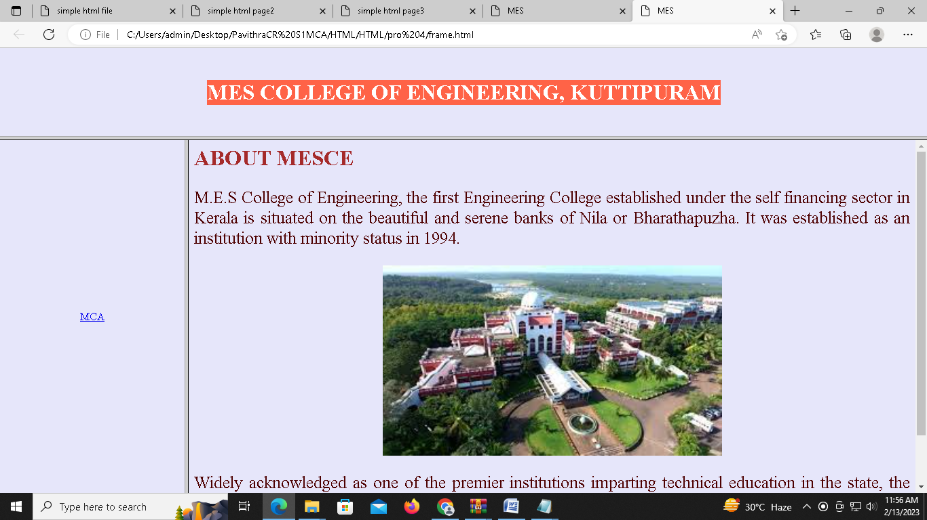

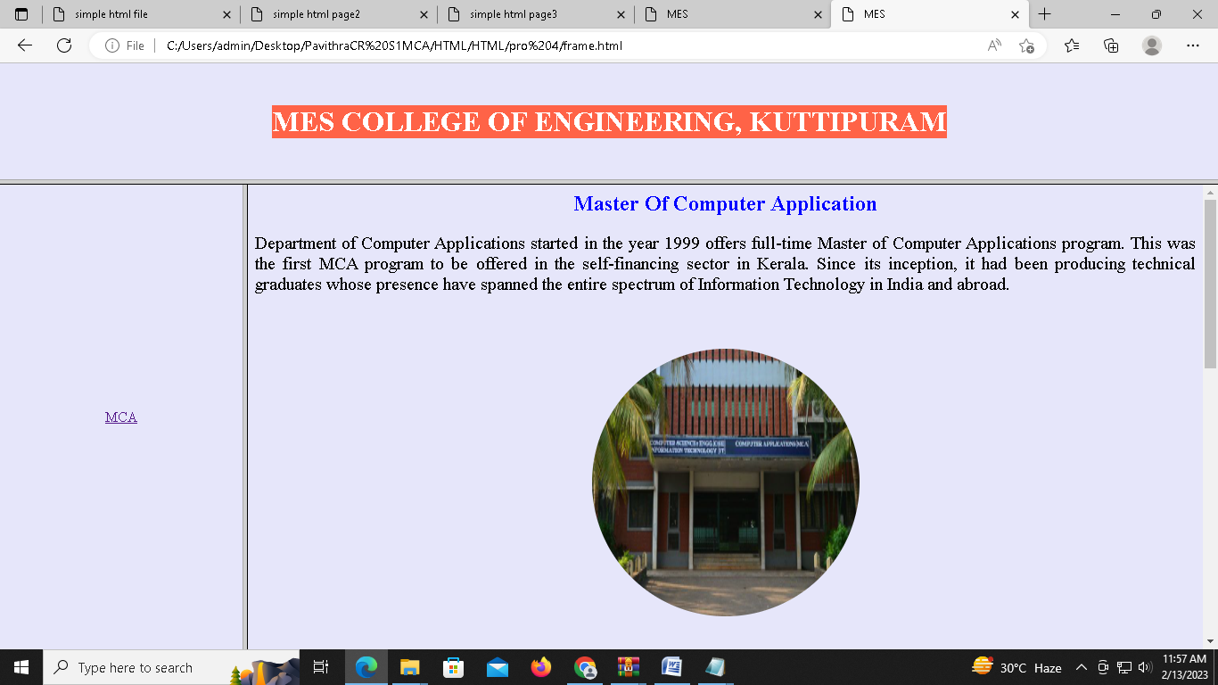

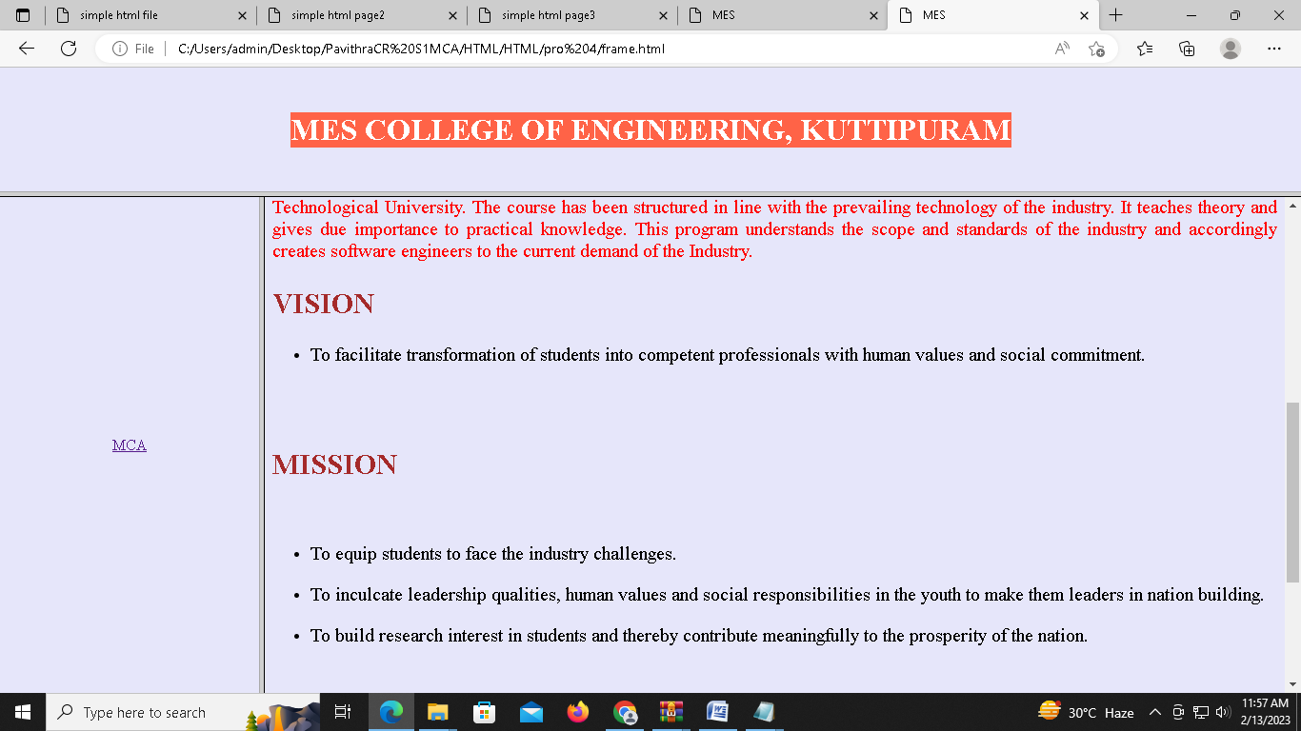

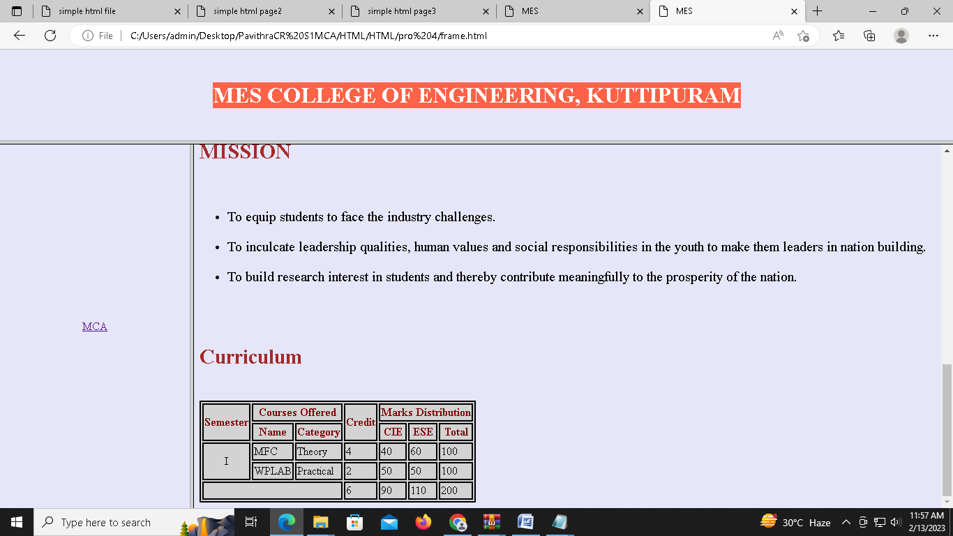

PROGRAM5:

<html>

<head>

<title>form</title>

<style>

.right

{

position:relative;

left:700px;

color:brown;

}

.body

{

background-color:powderblue;

}

.ad

{

position:relative;

left:-7;

}

.gen

{

position:relative;

left:1;

}

.date

{

position:relative;

left:-28;

}

.fl

{

width:500;

background-color:lavender;

}

.h3

{

position:absolute;

left:650;

top:370;

}

.h3_sub

{

position:absolute;

left:650;

top:395;

}

.other

{

position:relative;

left:50;

}

</style>

</head>

<body class="body">

<h2 class="right">Registration Form</h2>

<center>

<form>

<fieldset class="fl">

<legend align="left"><h3>Persional Information</h3></legend>

<label>Name : </label>

<select>

<option>Mr.</option>

<option>Ms.</option>

</select>

<input type="text" name="name" value="Enter Your Name" size="13"><br><br>

<label>Email : </label> <input type="email" name="email" value="eg;example@gmail.com"><br><br>

<label class="ad">Address : </label> <textarea class="ad" cols="21" rows="5" name="address" "></textarea><br><br>

<label class="gen">Gender : </label>

<input class="gen" type="radio" name="gender"><label class="gen">Male</label>

<input class="gen" type="radio" name="gender"><label class="gen">Female</label>

<input class="gen" type="radio" name="gender"><label class="gen">Other</label> <br><br>

<label class="date">DOB : </label> <input class="date" type="date" name="dob">

</fieldset>

</center>

<h3 class="h3">Languages Known</h3><br>

<p class="h3_sub">

<input type="checkbox" name="eng"> <label>English</label><br>

<input type="checkbox" name="mala"> <label>Malayalam</label><br>

<input type="checkbox" name="hin"> <label>Hindi</label><br><br>

<label>Select a File</label> <button value="choose"> Choose </button><br><br>

<input type="submit" name="submit" value="Submit"> <input type="reset" name="reset" value="Reset">

</p>

</form>

</body>

</html>

Output:

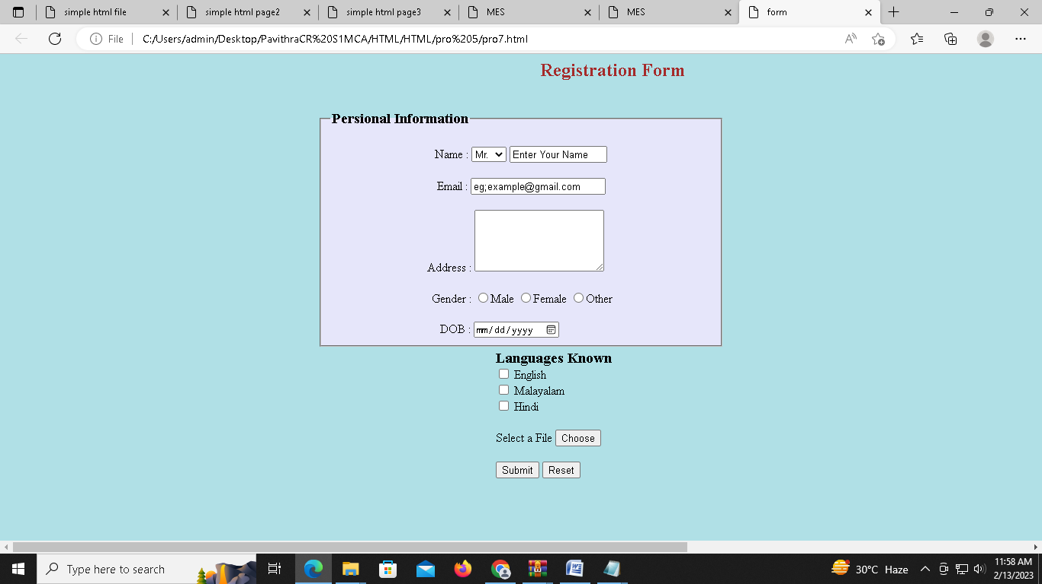

PHP:

PROGRAM1:

<?php

$nameError = $emailError = $genderError = $phonenoError ="";

$name = $email = $gender = $phoneno = $comment = "";

if($_POST){

if (empty($_POST["name"])) {

$nameError = "Name is required";

} else {

$name = test_input($_POST["name"]);

if (!preg_match("/^[a-zA-Z ]*$/",$name)) {

$nameError = "Only letters and white space allowed";

}

}

if (empty($_POST["email"])) {

$emailError = "Email is required";

} else {

$email = test_input($_POST["email"]);

if (!filter_var($email, FILTER_VALIDATE_EMAIL)) {

$emailError = "Invalid Email format";

}

}

if (empty($_POST["phoneno"])) {

$phonenoError = "Phone is required";

} else {

$phoneno = test_input($_POST["phoneno"]);

if(!preg_match("/^[0-9]{10}+$/", $phoneno)) {

$phonenoError= "Invalid Phone Number";

}

}

if (empty($_POST["comment"])) {

$comment="";

} else {

$comment = test_input($_POST["comment"]);

}

if (empty($_POST["gender"])) {

$genderError = "Gender is required";

} else {

$gender = test_input($_POST["gender"]);

}

}

function test_input($data) {

$data = trim($data);

$data = stripslashes($data);

$data = htmlspecialchars($data);

return $data;

}

?>

<html>

<head>

<title>Form Validation with PHP</title>

<style>

.error{

color:red

}

textarea{

width:250px;

height:60px;

border:none

}

.input{

width:300px;

height:25px;

margin-top:10px;

border:none;

}

form{

position:relative;

left:500;

width:440px;

padding: 20px ;

background-color:#a0f8ee;

}

</style>

</head>

<body>

<h2 align = "center">Form Validation with PHP</h2>

<form method="post">

<h2>Registration Form</h2>

<span class="error">* required field</span><br>

<span class="error">*</span>

Name:

<input class="input" name="name" type="text" value="<?= $name ?>"><br>

<span class="error"><?php echo $nameError;?></span><br><br>

<span class="error">*</span>

E-mail:

<input class="input" name="email" type="text" value="<?= $email ?>"><br>

<span class="error"><?php echo $emailError;?></span><br><br>

<span class="error">*</span>

Phone:

<input class="input" name="phoneno" type="text" value="<?= $phoneno ?>"><br>

<span class="error"><?php echo $phonenoError;?></span><br><br>

<span class="error">*</span>

Gender:

<input type="radio" name="gender" <?php if (isset($gender) && $gender == "female") echo "checked";?> value="female">Female

<input type="radio" name="gender" <?php if (isset($gender) && $gender == "male") echo "checked";?> value="male">Male

<input type="radio" name="gender" <?php if (isset($gender) && $gender == "other") echo "checked";?> value="other">Other<br>

<span class="error"><?php echo $genderError;?></span><br><br>

Comment:

<textarea cols="40" name="comment" rows="5">

</textarea><br><br>

<input name="submit" type="submit" value="Submit">

</form>

<?php

echo "<h1>Your Input:</h1><h2>";

echo $name;

echo "<br>";

echo $email;

echo "<br>";

echo $phoneno;

echo "<br>";

echo $gender;

echo "<br>";

echo $comment."</h2>";

?>

</body>

</html>

OUTPUT: 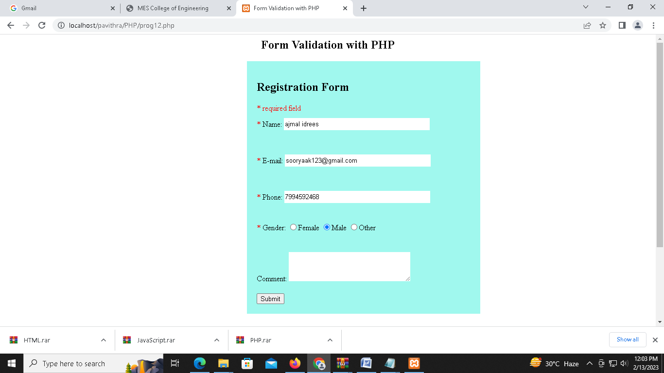

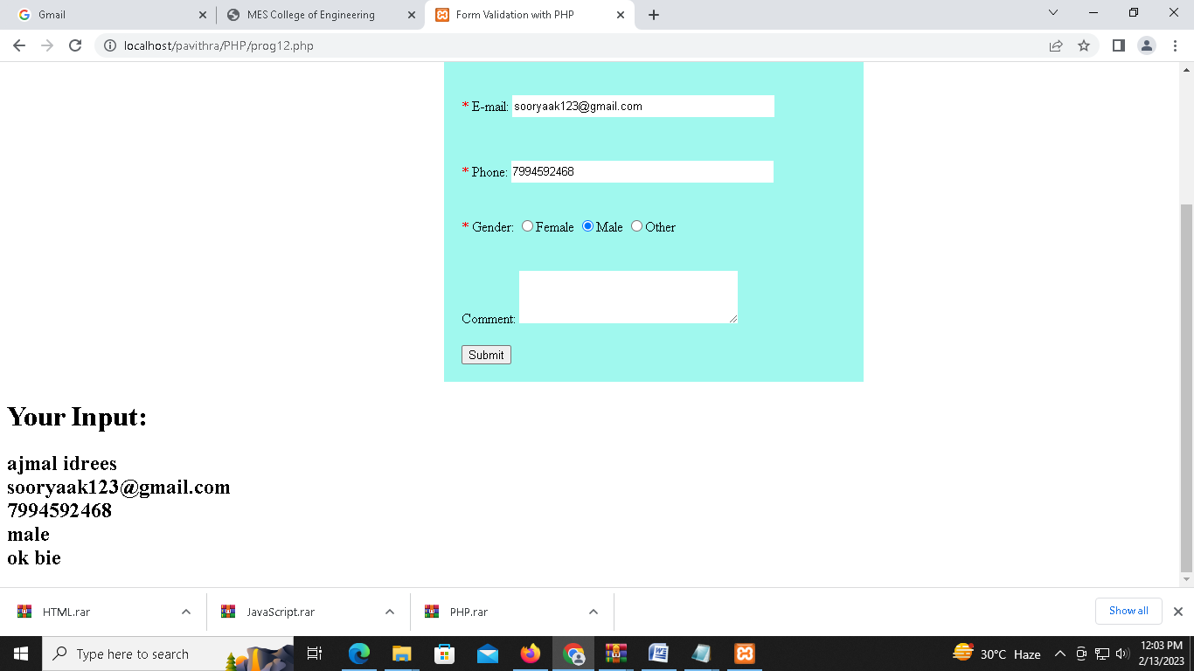

PROGRAM 2:

<html>

<head><style>input{border:solid 2px; padding:5px;font-size: 28px;}</style></head>

<body>

<h1>Php - Calculate Electricity Bill</h1>

<form method="post">

<input type="number" width="10px" name="units" placeholder="Please enter no. of Units" />

<input type="submit" name="unit-submit" value="Submit" />

</form>

</body>

<?php

$result_str = $result = '';

if (isset($_POST['unit-submit'])) {

$units = $_POST['units'];

if (!empty($units)) {

$result = calculate_bill($units);

$result_str = '<h2>Total amount of ' . $units . ' - ' . $result."</h2>";

echo $result_str;

}

}

function calculate_bill($units) {

$unit_cost_first = 3.50;

$unit_cost_second = 4.00;

$unit_cost_third = 5.20;

$unit_cost_fourth = 6.50;

if($units <= 50) {

$bill = $units * $unit_cost_first;

}

else if($units > 50 && $units <= 100) {

$temp = 50 * $unit_cost_first;

$remaining_units = $units - 50;

$bill = $temp + ($remaining_units * $unit_cost_second);

}

else if($units > 100 && $units <= 200) {

$temp = (50 * 3.5) + (100 * $unit_cost_second);

$remaining_units = $units - 150;

$bill = $temp + ($remaining_units * $unit_cost_third);

}

else {

$temp = (50 * 3.5) + (100 * $unit_cost_second) + (100 * $unit_cost_third);

$remaining_units = $units - 250;

$bill = $temp + ($remaining_units * $unit_cost_fourth);

}

return number_format((float)$bill, 2, '.', '');

}

?>

</html>

OUTPUT:

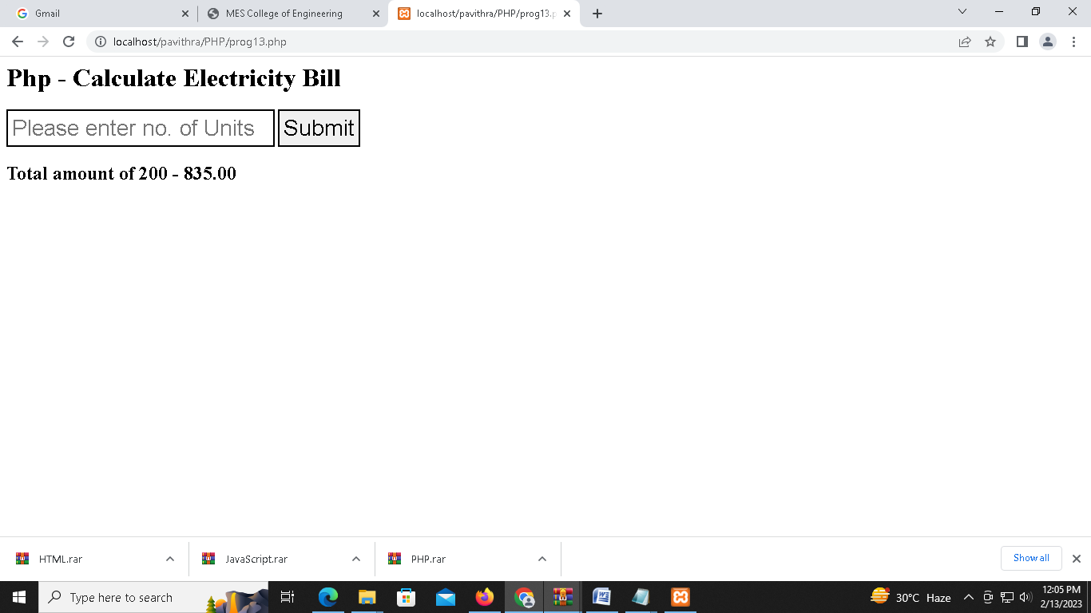

PROGRAM3:

<?php

$students=array("pra"=>"pranav","sha"=>"shaheen","mid"=>"midun","fala"=>"falahu","mush"=>"mushfique");

echo "<h2>";

print_r($students);

echo "<br><br>";

echo "The Array sorted using asort : <br>";

asort($students);

print_r($students);

echo "<br><br>";

echo "The Array sorted using arsort : <br>";

arsort($students);

print_r($students);

echo "</h2>";

?>

OUTPUT:

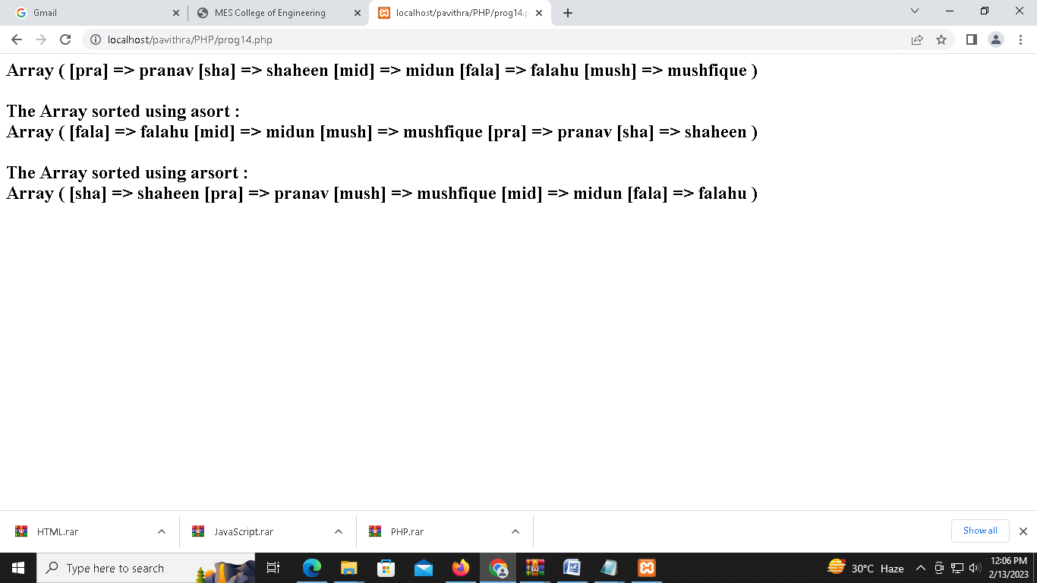

PROGRAM4:

<html>

<head>

<style>

.c

{

border: solid 1px; font-size:28px; padding: 3;}

</style>

</head>

<body>

<?php

$data= array(array('1','Sachin','Tendulkar'),array('2','Virat','Kohli'),array('3','MS','Dhoni'));

echo "<h1> Indian Cricket players </h1>";

echo "<table class=c>";

echo "<tr class=c><th class=c>NO</th><th class=c>First Name</th><th class=c>Last Name</th></tr>";

foreach ($data as $a)

{

echo "<tr class=c>";

foreach($a as $v)

{

echo "<td class=c>".$v."</td>";

}

echo "</tr>";

}

echo "</table>";

?>

</body>

</html>

OUTPUT:

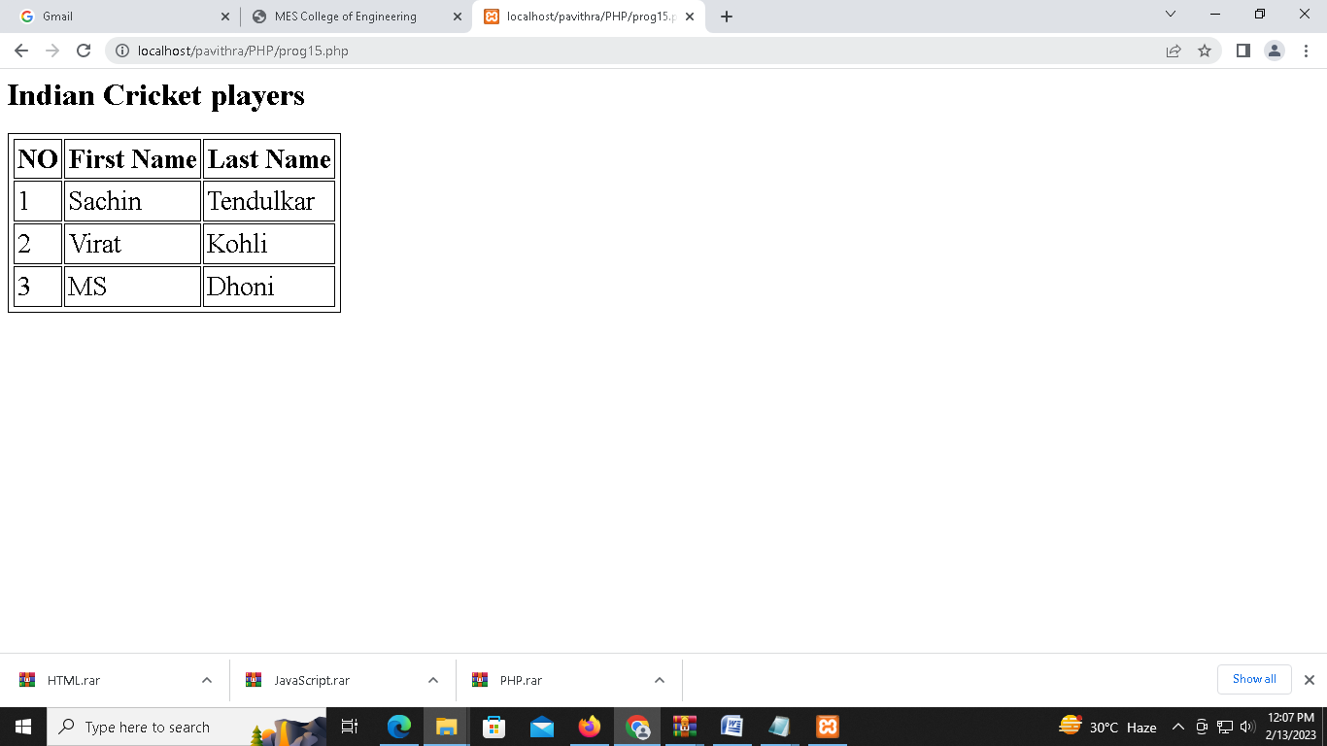

PROGRAM5:

<?php

$con=mysqli_connect("localhost","root","","college");

if(!$con)

{

echo "connection failed.!";

}

$result=$con->query("select * from students");

if($result==false)

{

echo "query failed.!";

}

else

{

echo "<h1><u> PHP - Database Connection </u></h1>";

while($row=$result->fetch_object())

{

echo "<h2>".$row->studname." , ".$row->email." , ".$row->dob."</h2>";

}

}

?>

OUTPUT:

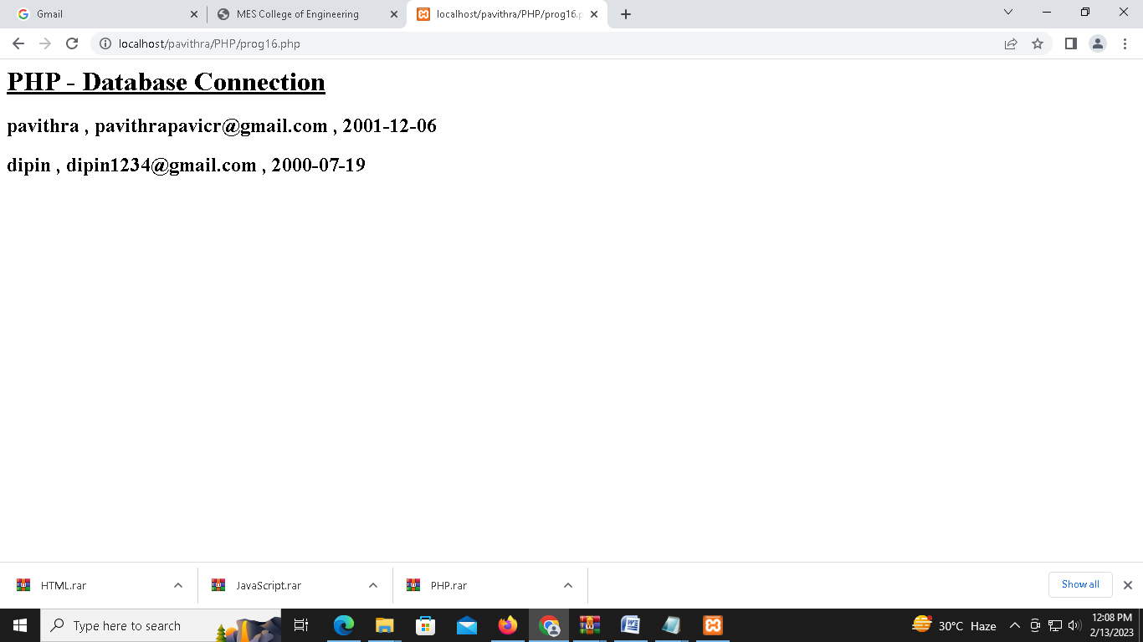

JAVASCRIPT:

PROGRAM1

<html>

<body>

<h2>String Predefined Functions & Math Object </h2>

<p id="ans1"></p>

<p></p>

<script>

document.write("<br><H3>String Functions</h3>");

var text = "Javascript is Simple.!";

document.write("<br>The String We Are Using : "+text);

var textre = text.replace("Simple","Powerfull");

document.write("<br><br>String Function Replace <b>'text.replace'</b> : "+textre);

var length = text.length;

document.write("<br><br>String Function length <b>'text.length'</b> : "+length);

var sliced= text.slice(14, 20);

document.write("<br><br>String Function Slicing <b>'text.slice(7,13)'</b> : "+sliced);

var upper = text.toUpperCase();

document.write("<br><br>String Function UpperCase <b>'text.toUpperCase'</b> : "+upper);

document.write("<br><BR><BR><H3>Math Objects</h3>");

var c =Math.ceil(3.5);

document.write("<BR>Math Object Ceil <b>'Math.ceil(3.5)'</b> : "+c);

var f =Math.floor(3.5);

document.write("<BR><br>Math Object Floor <b>'Math.floor(3.5)'</b> : "+f);

var po = Math.pow(8,2);

document.write("<BR><br>Math Object Power <b>'Math.pow(8,2)'</b> : "+po);

var pi=Math.PI;

document.write("<BR><br>Math Object PI <b>'Math.PI'</b> : "+pi);

</script>

</body>

</html>

OUTPUT:

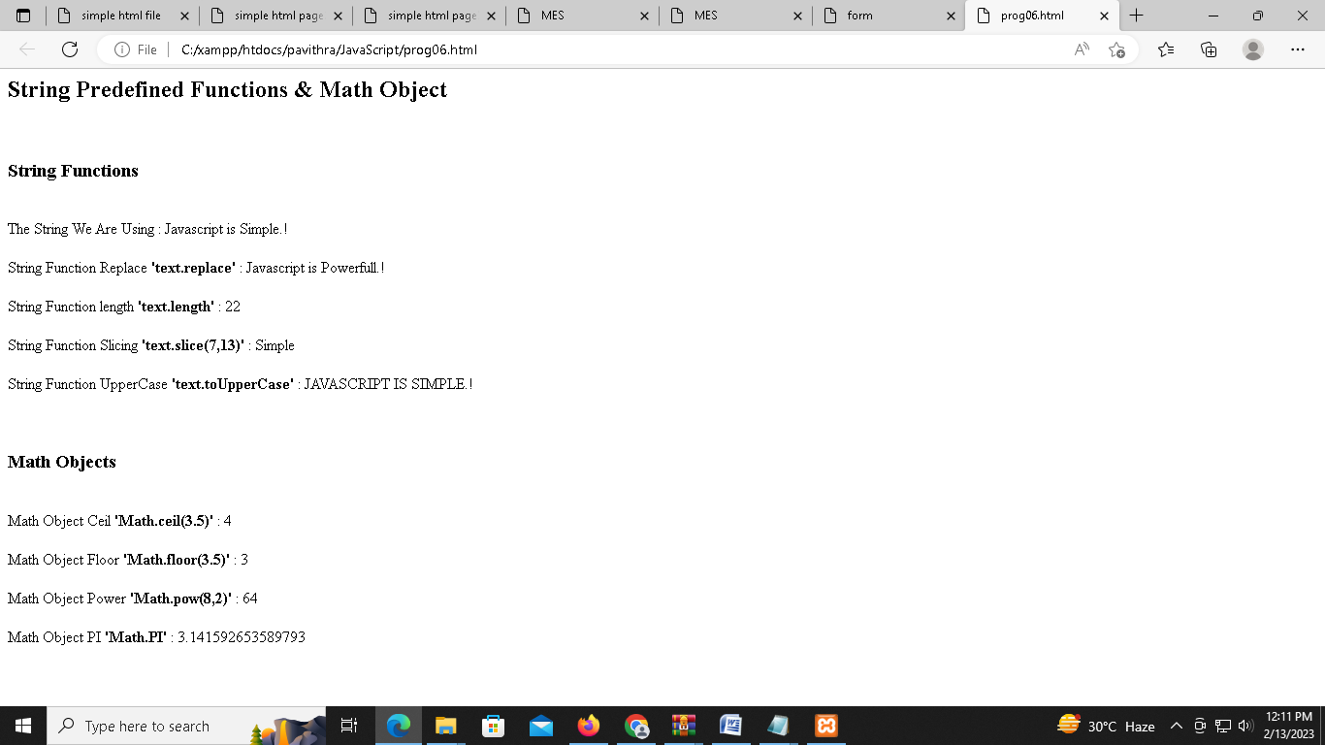

PROGRAM2:

<html>

<body>

<style>

table,

th,

tr,

td {

border: 2px solid;

padding: 2px 3px;

text-align: center;

}

table {

width: 60%;

}

th {

background-color: aquamarine;

}

</style>

<script>

function cal()

{

var mnth = document.getElementsByName('inputMnth')[0].value;

var year = document.getElementsByName('inputYear')[0].value;

var heading = document.getElementById('heading');

var dateString = mnth + " 1," + year;

heading.innerHTML = mnth.toUpperCase() + " &nbsp;" + year;

var tb = document.getElementById("t");

var dt = new Date(dateString);

var cellNum = dt.getDay();

const mnth31 = ["january", "march", "may", "july", "august", "october", "december"];

const mnth30 = ["april", "june", "september", "november"];

var count = 1;

for (var i = 1; i < 6; i++)

{

var cel = tb.rows.item(i).cells;

for (var j = cellNum; j < 7; j++)

{

cel.item(j).innerText = count++;

if (mnth31.includes(mnth.toLowerCase()))

{

if (count > 31)

break;

}

else if (mnth30.includes(mnth.toLowerCase()))

{

if (count > 30)

break;

}

else if (mnth == "February")

{

if (year % 400 == 0 || year % 4 == 0 && year % 100 != 0)

{

if (count > 29)

{

break;

}

}

else

{

if (count > 28)

{

break;

}

}

}

else

{

document.write("Enter Valid Month");

return 0;

}

}

cellNum = 0;

}

}

</script>

<center>

<label>Enter Month </label> &nbsp; &nbsp;

<input type="textbox" name="inputMnth"><br><br>

<label>Enter Year </label>&nbsp; &nbsp; &nbsp; &nbsp;

<input type="textbox" name="inputYear"><br><br>

&nbsp; &nbsp; &nbsp; &nbsp; &nbsp; &nbsp; &nbsp; &nbsp; &nbsp; &nbsp; &nbsp; &nbsp;

<button onClick="cal()">submit</button><br><br><br>

<b>

<h2><label id="heading"></label></h2>

</b>

<!-- <button onClick="showtable1()">submit</button> -->

<table id="t">

<th style="color: red;">Sun</th>

<th>Mon</th>

<th>Tue</th>

<th>Wed</th>

<th>Thu</th>

<th>Fri&nbsp; </th>

<th>Sat&nbsp; </th>

<tr style="background-color: rgb(186, 248, 248);">

<td style="color: red;">&nbsp;</td>

<td> </td>

<td> </td>

<td> </td>

<td> </td>

<td> </td>

<td> </td>

</tr>

<tr style="background-color: rgb(121, 242, 216);">

<td style="color: red;">&nbsp;</td>

<td> </td>

<td> </td>

<td> </td>

<td> </td>

<td> </td>

<td> </td>

</tr>

<tr style="background-color: rgb(186, 248, 248);">

<td style="color: red;">&nbsp;</td>

<td> </td>

<td> </td>

<td> </td>

<td> </td>

<td> </td>

<td> </td>

</tr>

<tr style="background-color: rgb(121, 242, 216);">

<td style="color: red;">&nbsp;</td>

<td> </td>

<td> </td>

<td> </td>

<td> </td>

<td> </td>

<td> </td>

</tr>

<tr style="background-color: rgb(186, 248, 248);">

<td style="color: red;">&nbsp;</td>

<td> </td>

<td> </td>

<td> </td>

<td> </td>

<td> </td>

<td> </td>

</tr>

</table>

</center>

</body>

</html>

OUTPUT:

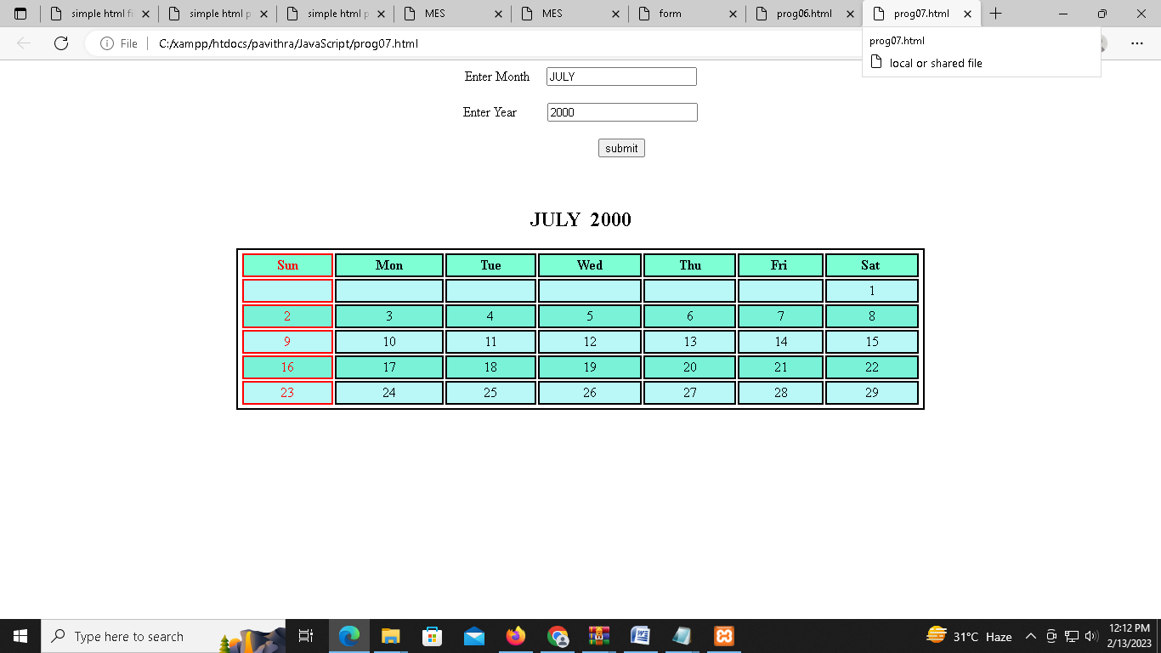

PROGRAM3:

<!DOCTYPE html>

<html>

<head>

<title>Welcome To Registration Form</title>

<script>

function registration()

{

var name= document.getElementById("t1").value;

var phone= document.getElementById("t2").value;

var g1=document.getElementById("g1").checked;

var g2=document.getElementById("g2").checked;

var g3=document.getElementById("g3").checked;

var comment= document.getElementById("c1").value;

var phoneno = /^\d{10}$/;

var letters = /^[A-Za-z]+$/;

if(name=='')

{

alert('Please enter your name.!');

}

else if(!letters.test(name))

{

alert('Name field required only alphabet characters.!');

}

else if(phone=='')

{

alert('Please enter your phone number.!');

}

else if (isNaN(phone))

{

alert('Invalid Phone Number.!');

}

else if (!phoneno.test(phone))

{

alert('Not Valid Phone Number (need 10 digits).!');

}

else if ((g1=="")&&(g2=="")&&(g3==""))

{

alert('You must select Gender');

}

else

{

alert('Thank You for Registration & You are Redirecting to Website');

}

}

</script>

</head>

<body>

<center>

<h2>Register Form Validation</h2>

<form style="width:500px;position: relative;left: 500;" >

<fieldset " >

<legend>Validation</legend>

<table cellspacing="2" align="center" cellpadding="8" border="0">

<tr>

<td align="right">Enter Name :</td>

<td><input type="text" placeholder="Enter name here" id="t1"></td>

</tr>

<tr>

<td align="right">Enter Phone Number :</td>

<td><input type="text" placeholder="Enter Phone Number here" id="t2"> </td>

</tr>

<tr>

<td align="right">Gender :</td>

<td><input type="radio" name="gender" value="male" id="g1"> Male

<input type="radio" name="gender" value="female" id="g2"> Female

<input type="radio" name="gender" value="other" id="g3"> Other</td>

</tr>

<tr>

<td align="right">Comment :</td>

<td><textarea cols="20" rows="5" name="comment" id="c1"></textarea></td>

</tr>

<tr>

<td></td>

<td>

<input type="reset" value="Clear Form" id="res">

<input type="submit" value="Create Account" onclick="registration()" /></td>

</tr>

</table>

</fieldset>

</form>

</center>

</body>

</html>

OUTPUT:

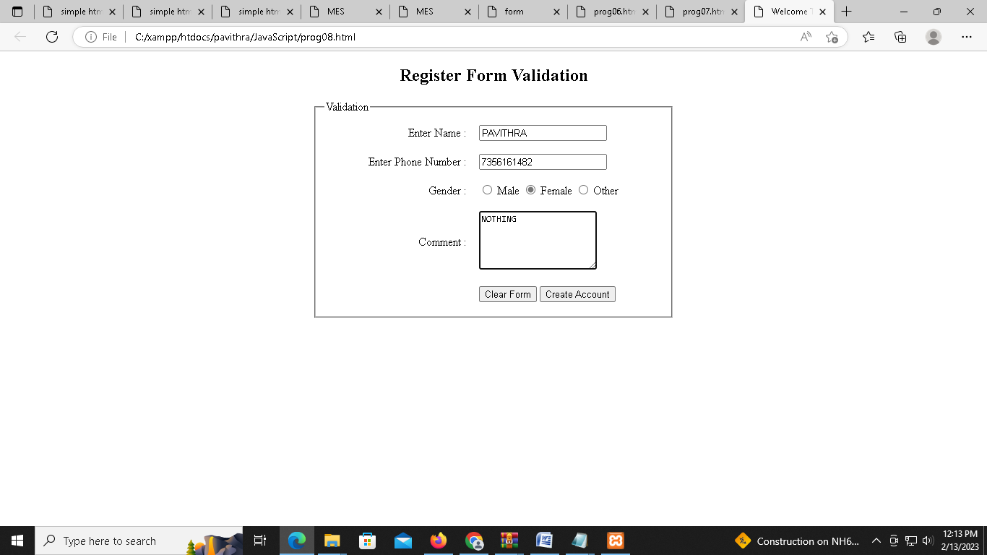

PROGRAM 4:

<html>

<head>

<script>

function myFun()

{

var r=Math.floor(Math.random()*256);

var g=Math.floor(Math.random()*256);

var b=Math.floor(Math.random()*256);

document.body.style.backgroundColor="rgb("+ r +","+ g +","+ b +")";

}

</script>

<style>

button

{

position: absolute;

top: 50%;

left: 50%;

padding: 15px;

font-size: 15px;

}

</style>

</head>

<body>

<button onclick="myFun()">Change Color</button>

</body>

</html>

OUTPUT:

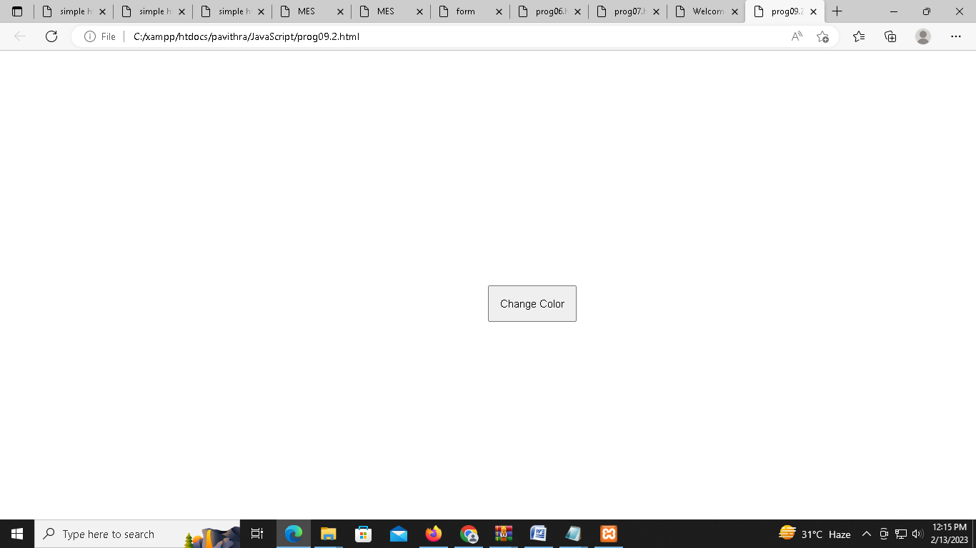

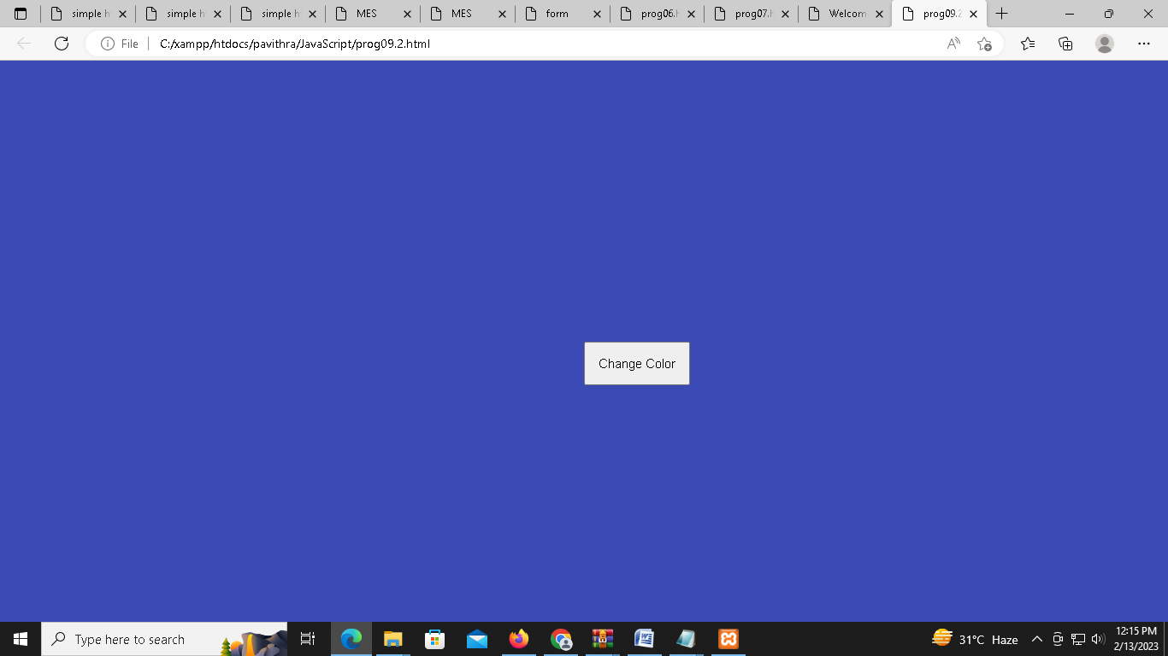

PROGRAM5:

<html>

<body>

<style>

img

{

position: absolute;

left:460;

top:50;

border-radius: 700px;

height: 590px;

width: 590px;

}

p

{

position: relative;

top: 650;

left: 630;

font-size: 28px;

}

</style>

<script>

function first()

{

document.getElementById("img").src="img1.jpeg";

document.getElementById("p").innerHTML="<font color=magenta>NOW onmouseover</font>";

}

function second()

{

document.getElementById("img").src="img2.jpeg";

document.getElementById("p").innerHTML="<font color=red>NOW onmouseout</font>";

}

</script>

<img src="img3.jpeg" id="img" onmouseover="first()" onmouseout="second()">

<b><p id="p"></p></b>

</body>

</html>

OUTPUT:

